**MODULE 1:**

Home page where in each command connects to various other forms .

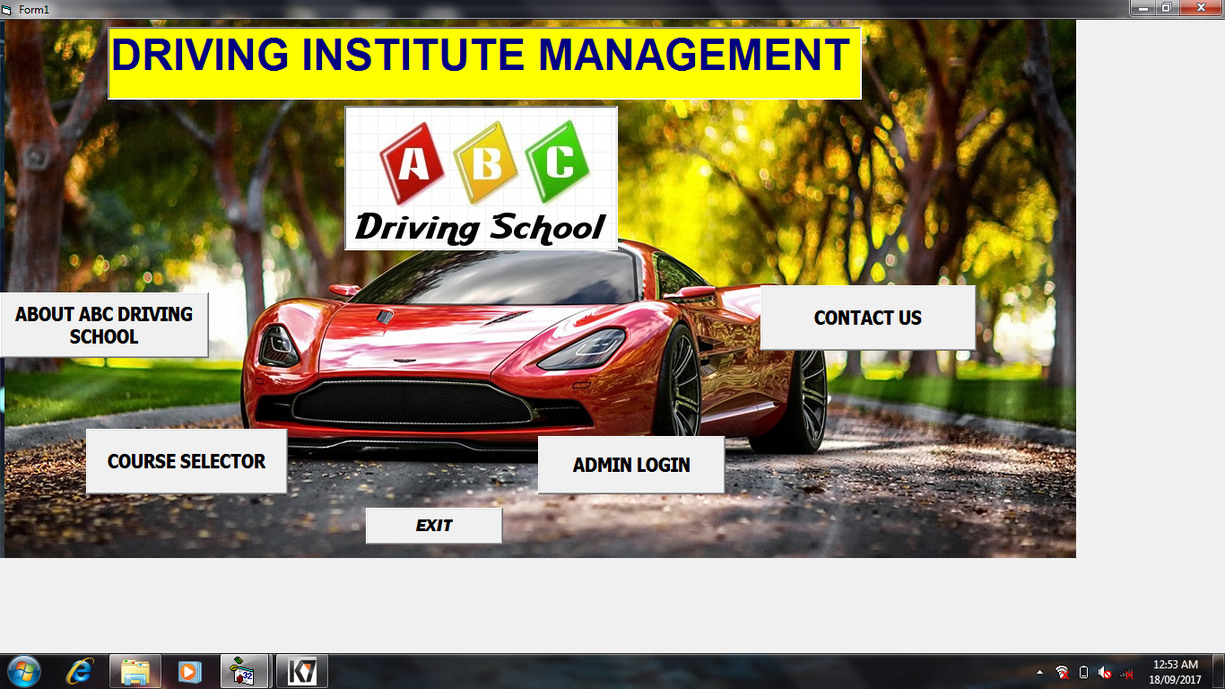

**FORM1 CODE:**

Private Sub Command1_Click()

Form2.Show

Form1.Hide

End Sub

Private Sub Command2_Click()

Form3.Show

Form1.Hide

End Sub

Private Sub Command3_Click()

Form7.Show

Form1.Hide

End Sub

Private Sub Command4_Click()

Form8.Show

Form1.Hide

End Sub

Private Sub Command5_Click()

End

End Sub

**MODULE 2:**

User interface window and This displays about the driving school and its motto and back button will lead back to the home page.

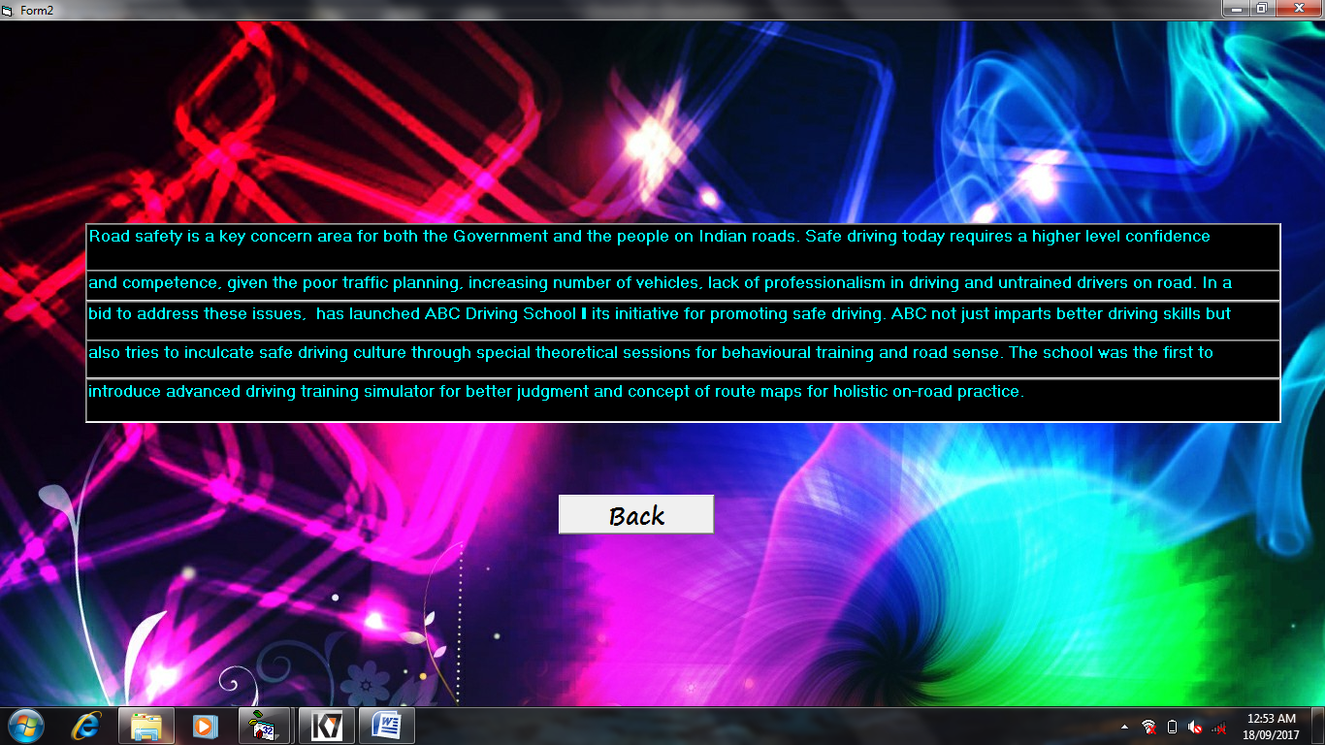

**FORM 2 CODE:**

Private Sub Command1_Click()

Form1.Show

Form2.Hide

End Sub

**MODULE 3:**

User interface window wherein the user can choose his course(course selector).

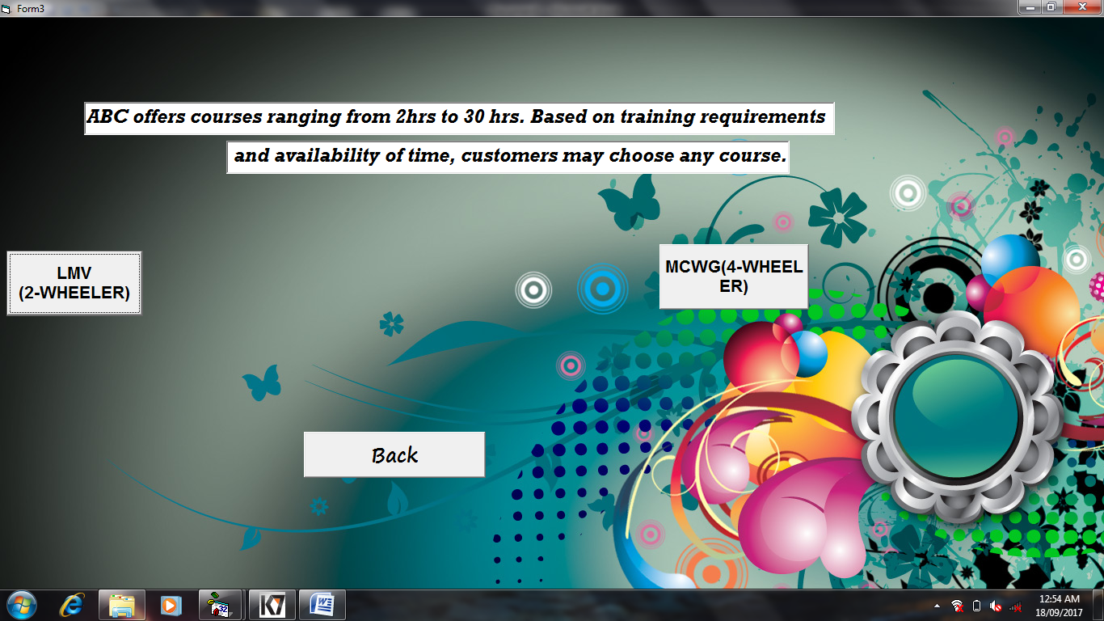

**FORM3 CODE:**

Private Sub Command1_Click()

Form4.Show

Form3.Hide

End Sub

Private Sub Command2_Click()

Form6.Show

Form3.Hide

End Sub

Private Sub Command3_Click()

Form1.Show

Form3.Hide

End Sub

**MODULE 4:**

User interface window which Displays training requirements and leads to registration form and the back option will lead back to the course selector window.

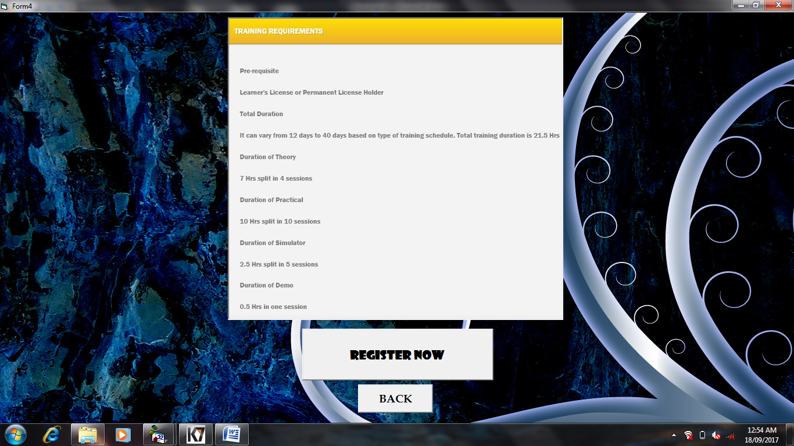

**FORM4 CODE:**

Private Sub Command1_Click()

Form5.Show

Form4.Hide

End Sub

Private Sub Command2_Click()

Form3.Show

Form4.Hide

End Sub

**MODULE 5:**

User registration window for 2-wheeler which can also search, update record.

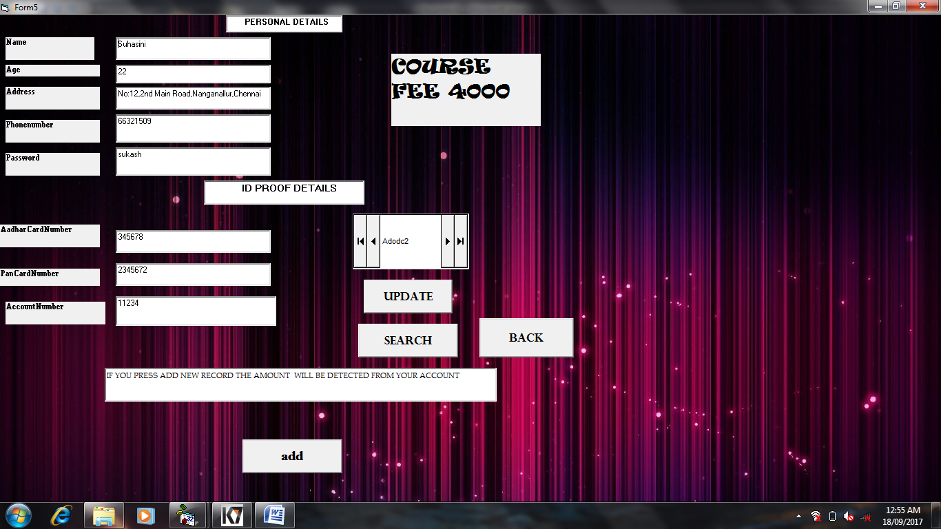

**FORM5 CODE:**

Private Sub Command1_Click()

Adodc2.Recordset.Update

MsgBox "updated"

End Sub

Private Sub Command2_Click()

Adodc2.Recordset.AddNew

MsgBox "registered"

End Sub

Private Sub Command3_Click()

Form4.Show

Form5.Hide

End Sub

Private Sub S_Click()

i = InputBox("ENTER THE CUSTOMER PASSWORD")

Adodc2.Recordset.MoveFirst

Do Until Adodc2.Recordset.EOF = True

If Text5.Text = i Then

Exit Sub

Else

Adodc2.Recordset.MoveNext

End If

Loop

MsgBox ("incorrect password")

End Sub

**MODULE 6:**

User registration window for 4-wheeler which can also search, update record.

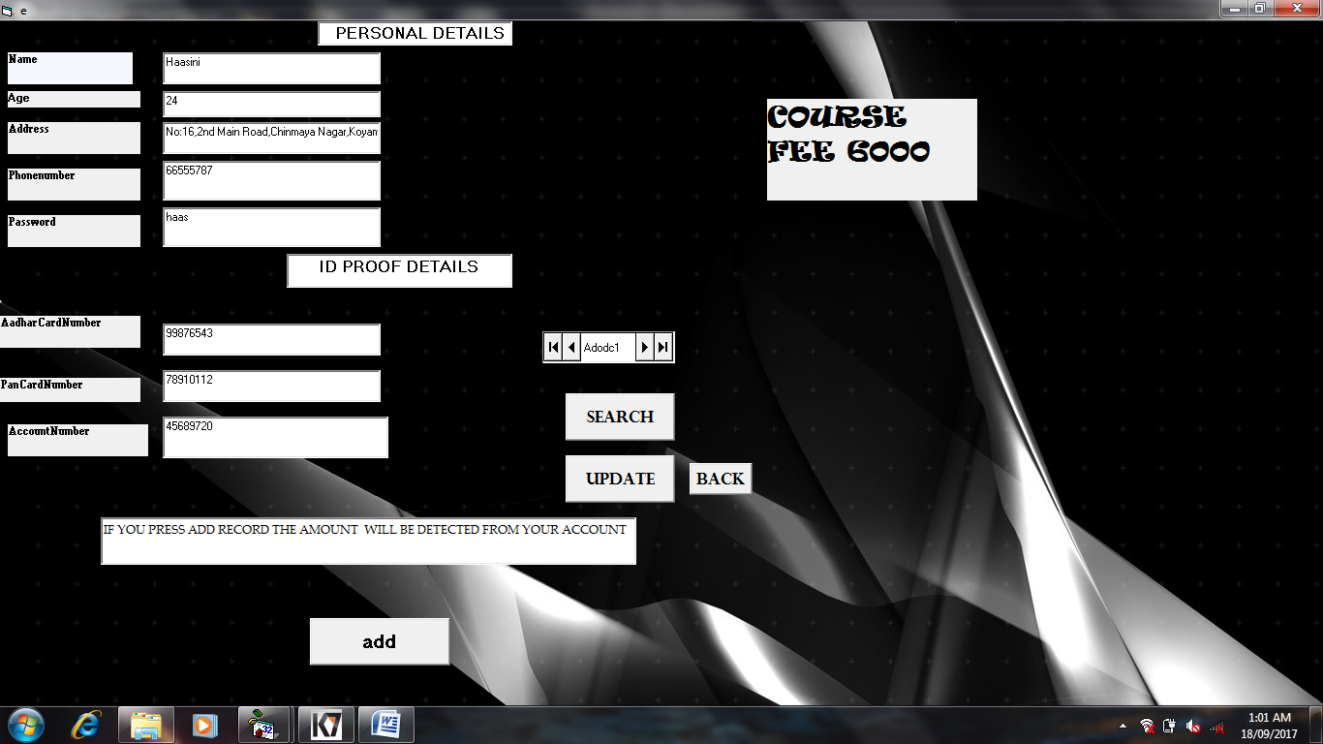

**FORM6 CODE:**

Private Sub Command1_Click()

Adodc1.Recordset.Update

MsgBox "updated"

End Sub

Private Sub Command2_Click()

Adodc1.Recordset.AddNew

MsgBox "registered"

End Sub

Private Sub Command3_Click()

i = InputBox("ENTER THE CUSTOMER PASSWORD")

Adodc1.Recordset.MoveFirst

Do Until Adodc1.Recordset.EOF = True

If Text5.Text = i Then

Exit Sub

Else

Adodc1.Recordset.MoveNext

End If

Loop

MsgBox ("incorrect password")

End Sub

Private Sub Command4_Click()

Form4.Show

Form6.Hide

End Sub

**MODULE 7:**

Admin login.

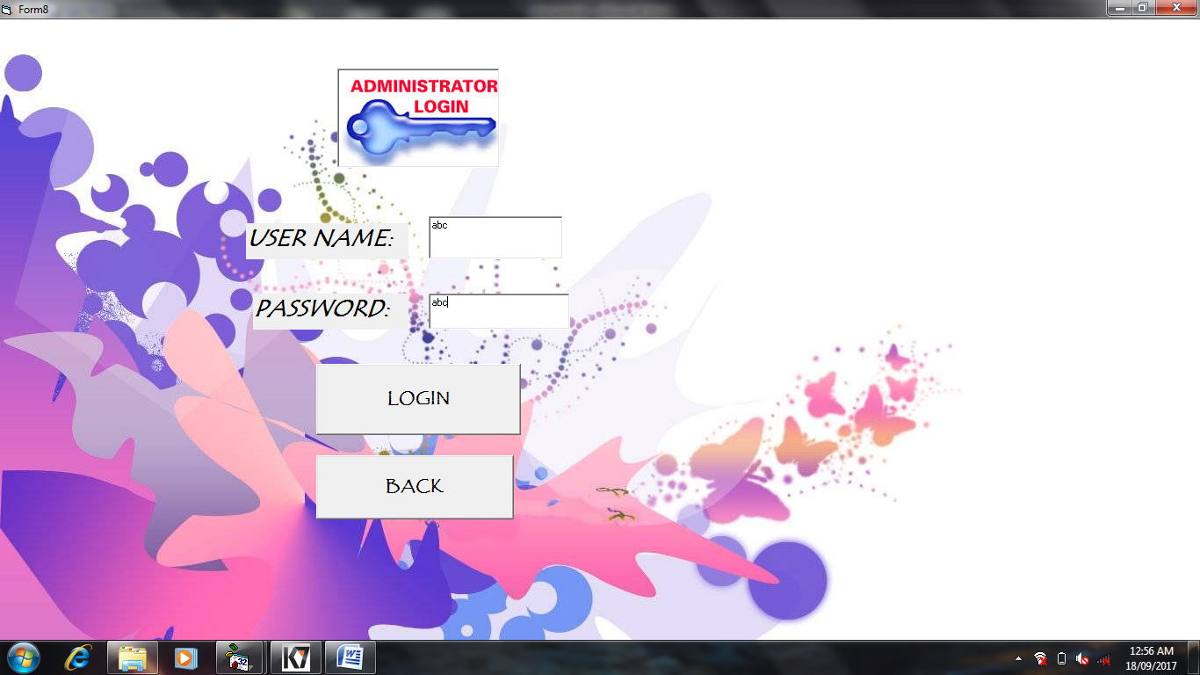

**FORM8 CODE:**

Private Sub Command1_Click()

If Text1.Text = "abc" And Text2.Text = "abc" Then

MsgBox "the password you entered is correct"

Form9.Show

Form8.Hide

Else

MsgBox "YOUR LOGIN IS DENIED"

End If

End Sub

Private Sub Command2_Click()

Form1.Show

Form8.Hide

End Sub

**MODULE 8:**

Admin interface where in the admin can delete particular records of both 2-wheeler and 4-wheeler applicants. Records are deleted on the basis of customer name. Back will lead back to admin login.

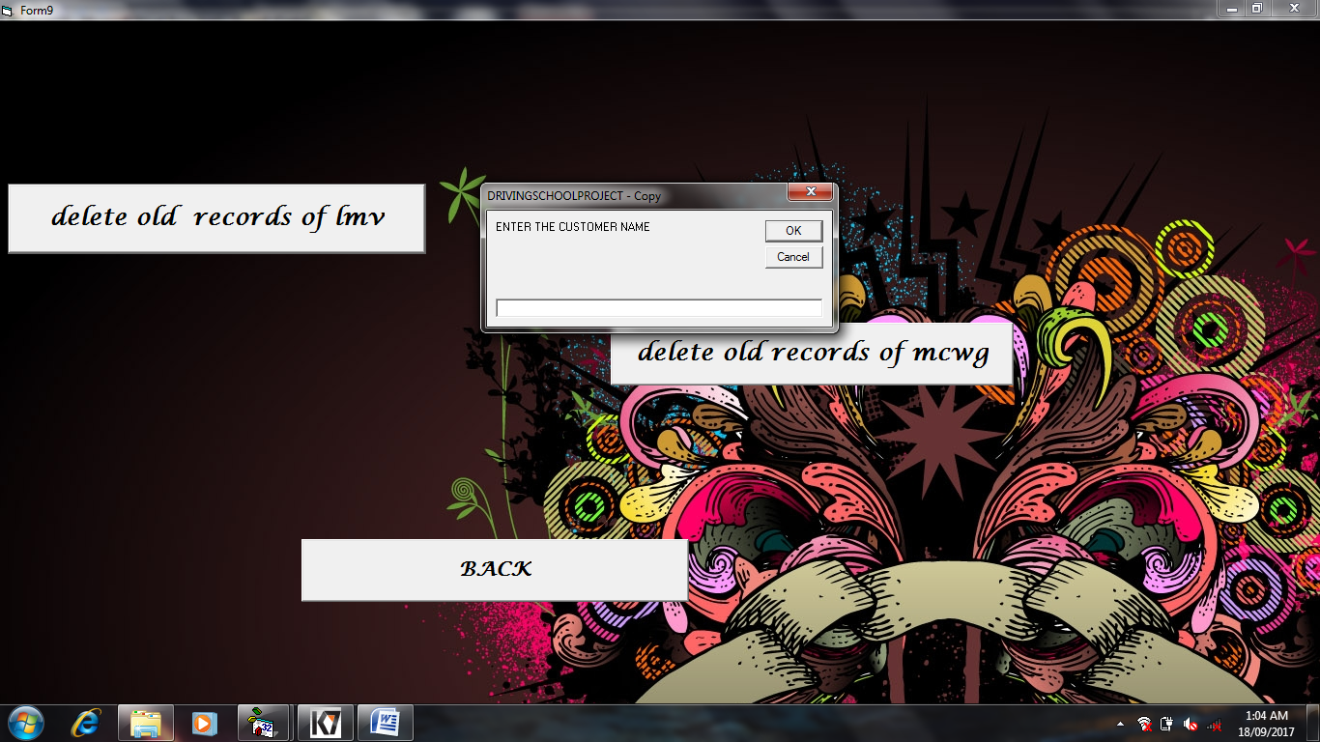

**FORM9 CODE:**

Private Sub Command1_Click()

i = InputBox("ENTER THE CUSTOMER NAME")

Form5.Adodc2.Recordset.MoveFirst

Do Until Form5.Adodc2.Recordset.EOF = True

If Form5.Text1.Text = i Then

Form5.Adodc2.Recordset.Delete

MsgBox "record deleted"

Exit Sub

Else

Form5.Adodc2.Recordset.MoveNext

End If

Loop

MsgBox ("NO RECORD FOUND")

End Sub

Private Sub Command2_Click()

Form8.Show

Form9.Hide

End Sub

Private Sub Command3_Click()

i = InputBox("ENTER THE CUSTOMER NAME")

Form6.Adodc1.Recordset.MoveFirst

Do Until Form6.Adodc1.Recordset.EOF = True

If Form6.Text1.Text = i Then

Form6.Adodc1.Recordset.Delete

MsgBox "record deleted"

Exit Sub

Else

Form6.Adodc1.Recordset.MoveNext

End If

Loop

MsgBox ("NO RECORD FOUND")

End Sub

**MODULE 9:**

Displays driving school contact details and back will lead bact to the home page.

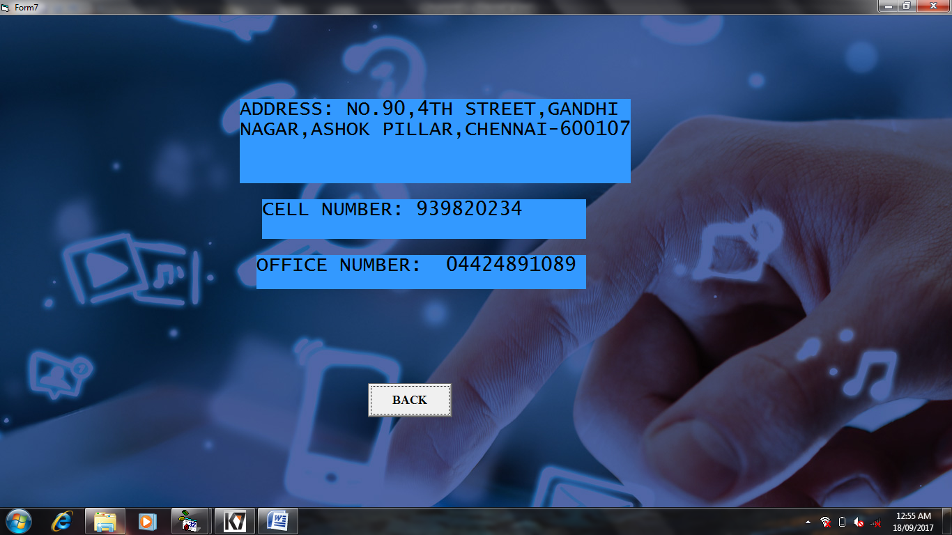

**FORM7 CODE:**

Private Sub Command1_Click()

Form1.Show

Form7.Hide

End Sub

**RESULT:**

The implementation of DRIVING SCHOOL MANAGEMENT SYSTEM is successfully executed using Visual Basic and MS Access.